

COLD PRESS JUICER

150W / AC220V-240V / 50Hz Model: SOL-JUC-121
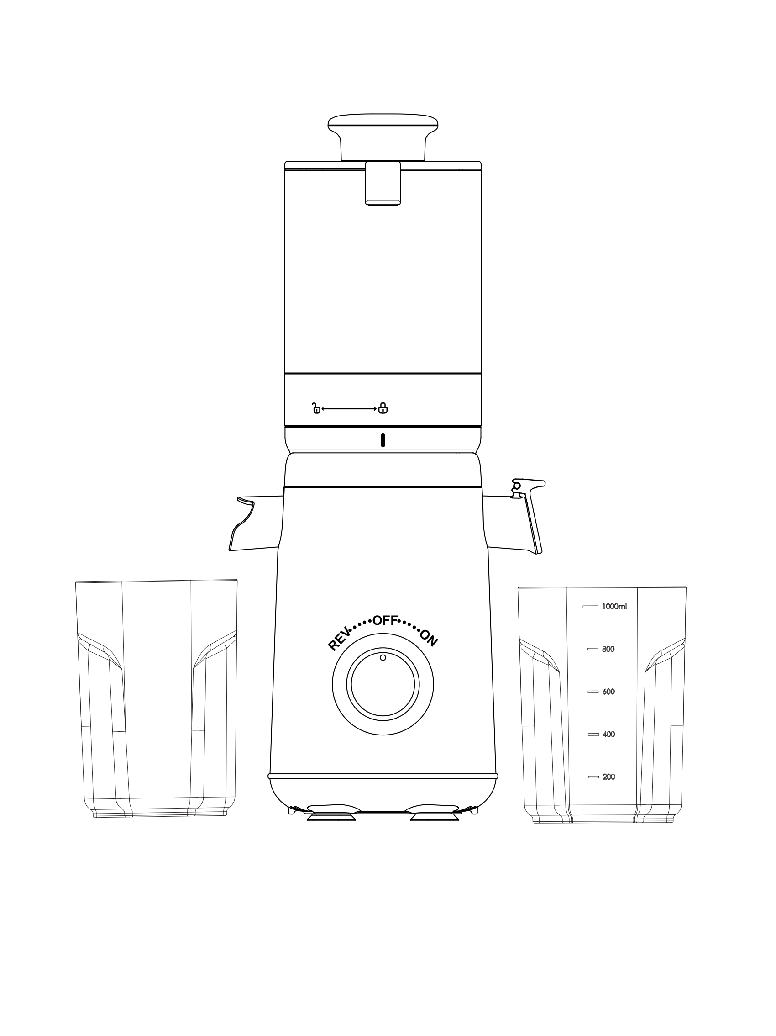
INSTRUCTION MANUAL

Please read and save all instructions to ensure safe and effective use of this appliance.


TABLE OF CONTENTS
Welcome to the SOLARA Family! 3
Before You Begin 4
General Safety Regulations 4
Know Your SOLARA Cold Press Juicer 5
Juicer Assembly 6
Juicer Disassembly 9
Operating the SOLARA Cold Press Juicer 11
Juicy Tips & Tricks 11
Care & Maintenance 12
Troubleshooting 12

Welcome to the SOLARA Family!

At SOLARA, we are all about making healthy choices. And eating healthy should always be considered in this journey. Truly we are what we eat. So, here we are with an awesome appliance to aid you in this journey. Also, we are constantly working to create EASY, TASTY & HEALTHY recipes for you!

We can’t wait to see how you make the SOLARA COLD PRESS JUICER part of your everyday, please feel free to share it with us on social media: @solaraindia.

Before You Begin
- Remove all packaging materials from in and around the juicer and verify that all parts are accounted for.
- Place the juicer on a stable, level surface, away from external heat sources.
- Read all Important safeguards and cautionary information in this user guide. Failure to do so may result in property damage and/or personal injury.
- Follow care & maintenance instructions in this user guide to clean the juicer before/after juicing.
- Do not remove safety warning stickers or rating label.

General Safety Regulations

When using electrical appliances, basic safety precautions should always be followed including the followings.
READ ALL INSTRUCTIONS BEFORE USING & SAVE THESE INSTRUCTIONS

- To protect against electrical shock, do not immerse cord, plug, or main body (motor) in water or other liquid.
- Close supervision is necessary when any appliance is used by or near children.
- Unplug from outlet before assembling, before taking off parts, before cleaning and when not in use.
- Do not operate any appliance with a damaged cord or plug or after the appliance malfunctions or has been damaged in any manner.
- The use of attachments not recommended or sold by manufacturer may cause fire, electric shock, or injury.
- This appliance is not intended for use by persons (including children) with reduced physical, sensory, or mental capabilities, or lack of experience and knowledge, unless they have been given supervision or instruction concerning use of the appliance by a person responsible for their safety.
- Always securely clamp in place all parts before the motor is turned on. Do not unfasten while appliance is in operation.
- Avoid contacting moving parts. Make sure that the motor stops completely before disassembling.
- Do not place on or near a hot gas or electric burner, or in a heated oven.
- Do not walk away from the appliance when it is in operation
- Do not disassemble the Base or tamper with it in any other way as this will negate the warranty.
- Do not put any foreign materials into the machine.
- Do not let cord hang over edge of table or counter or touch heated surfaces.
- To disconnect, press/switch OFF then remove plug from wall outlet. Make sure the motor stops completely before disassembling.
- Do not operate the juicer for more than 10 mins at a time. Always make to sure wait 10 mins before operating again.

Know Your SOLARA Cold Press Juicer

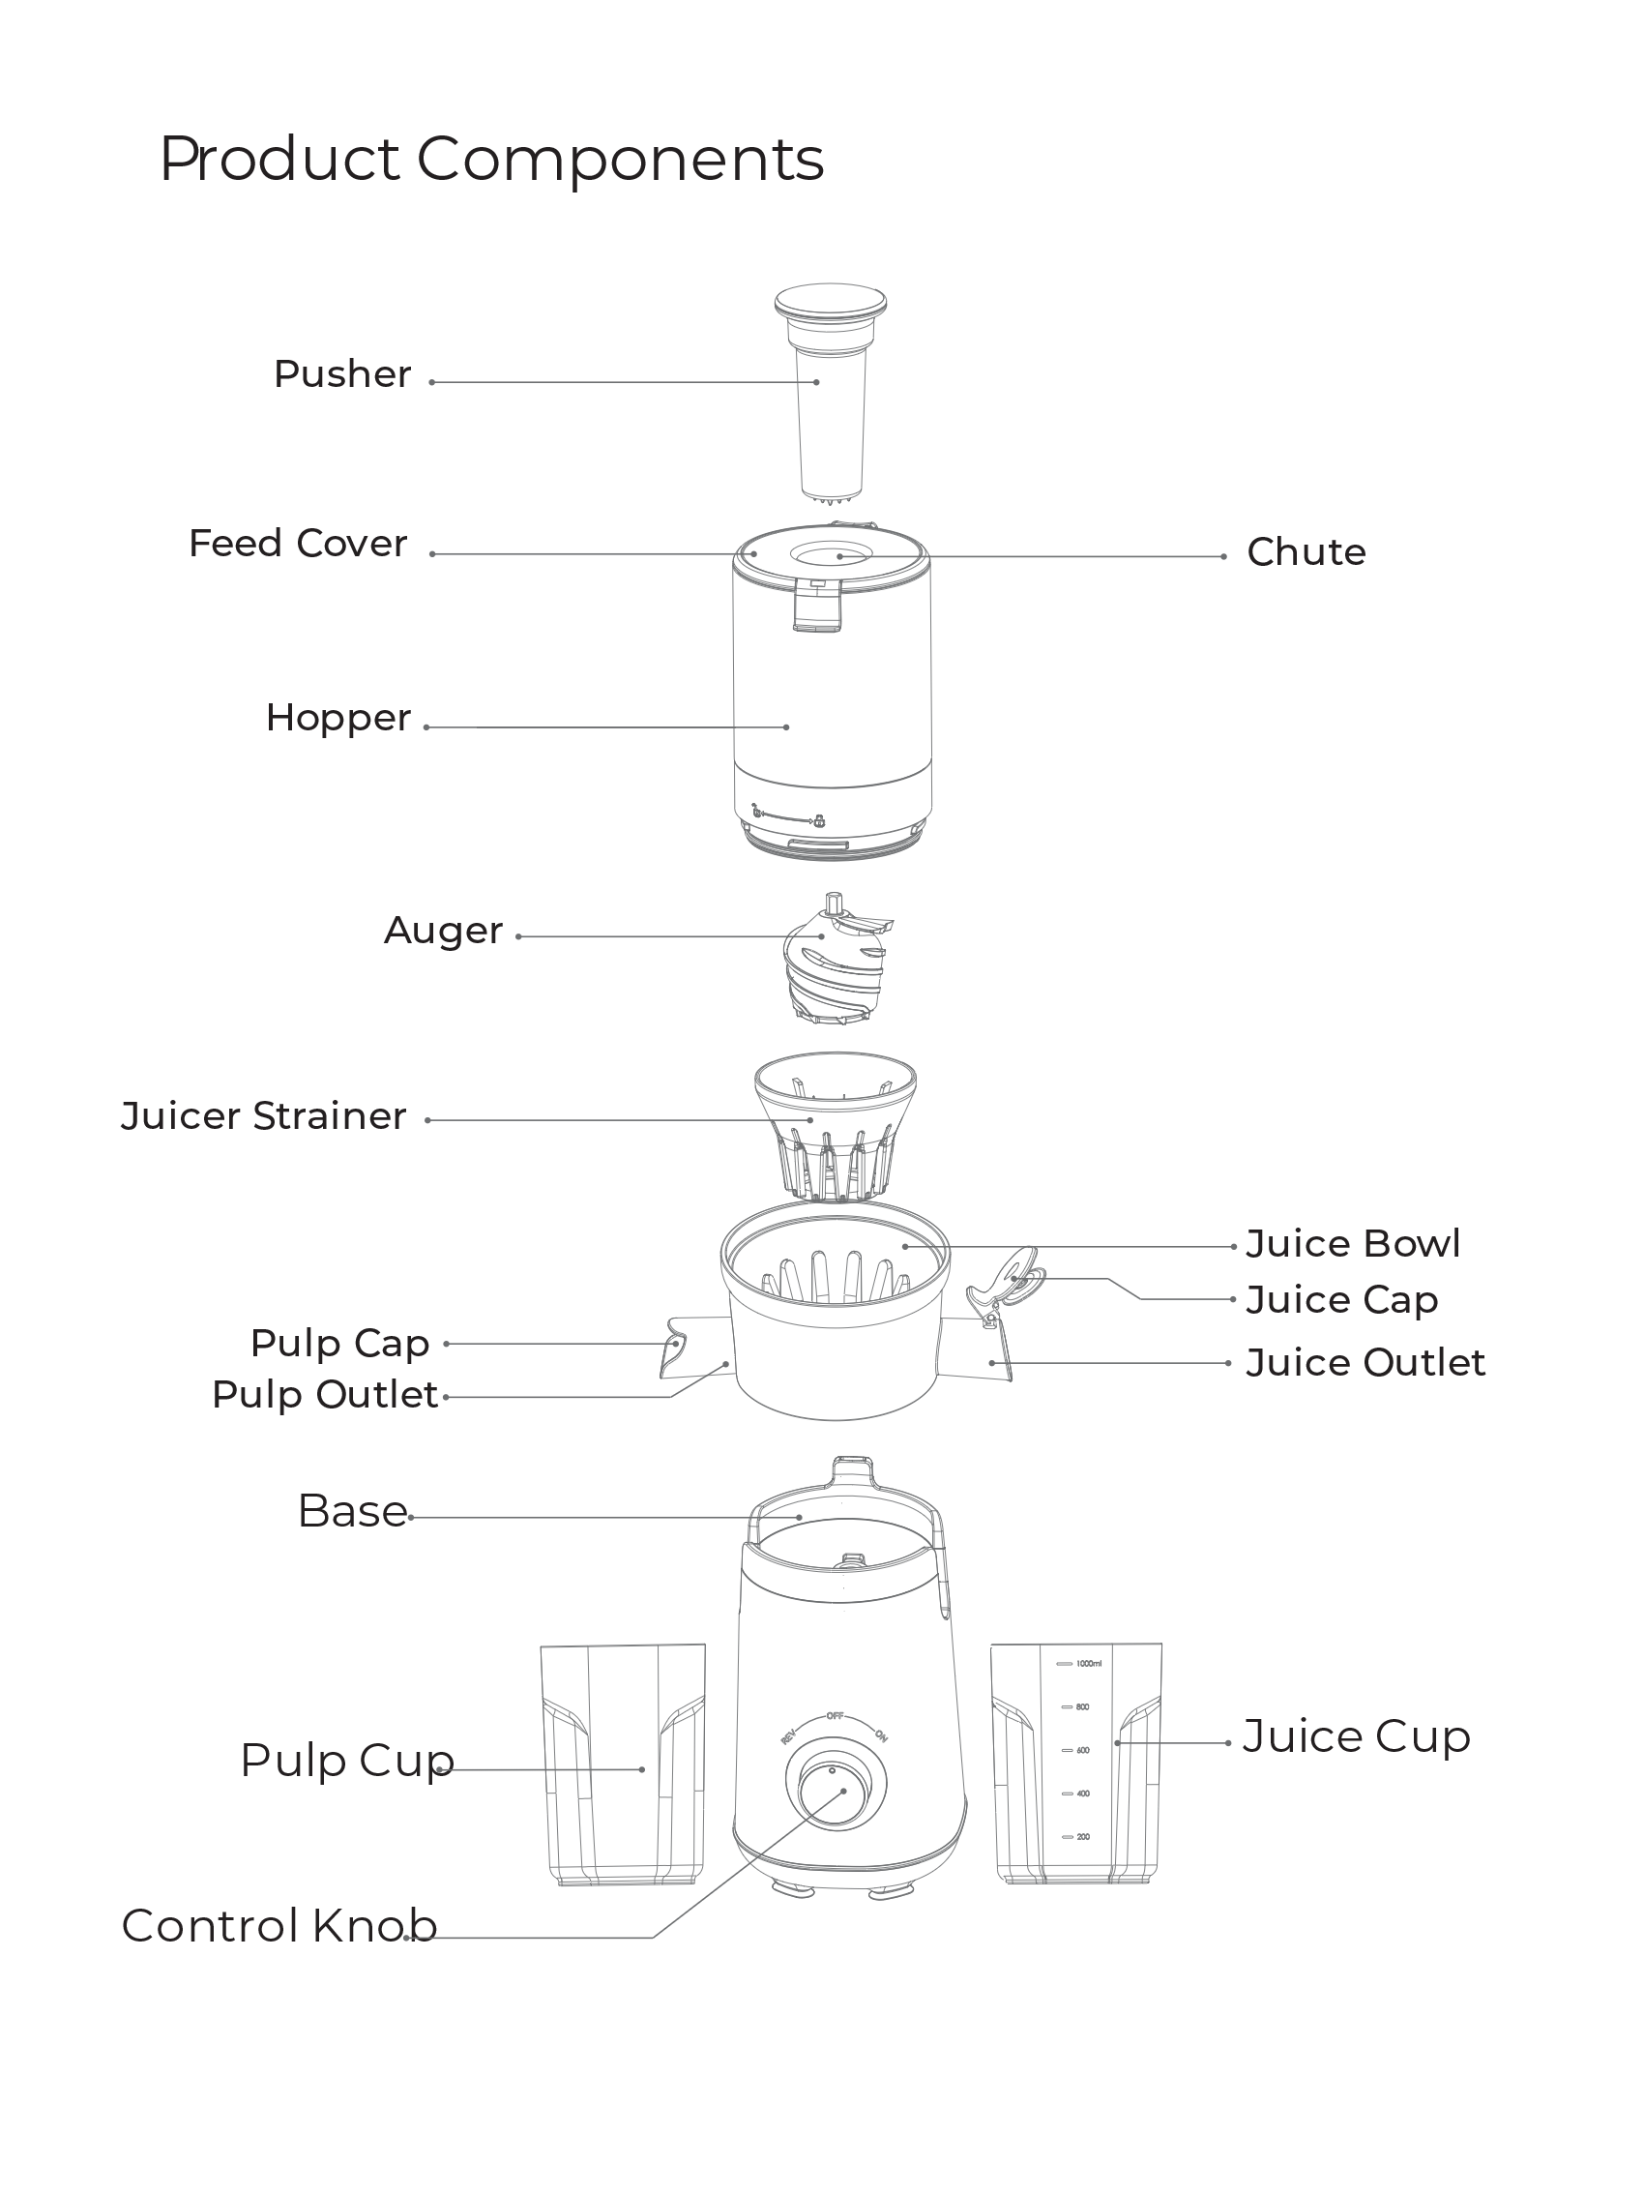

JUICER ASSEMBLY
Before first use, please rinse all detachable parts in warm and soapy water and fully dry them before assembly. Do not wash the base unit, simple wipe clean with a clean damp cloth. Prepare your juicing ingredients and keep them easily accessible. Use the steps below to safely assemble the juicer.

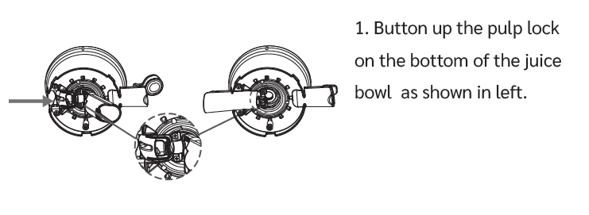
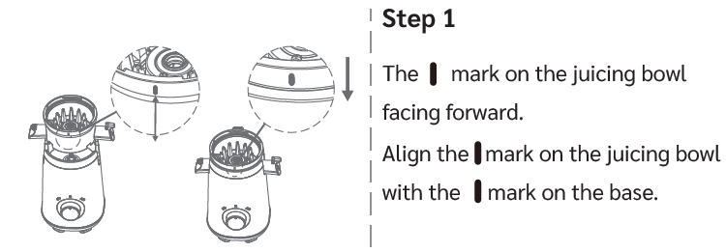

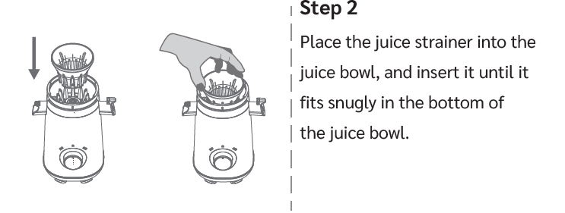

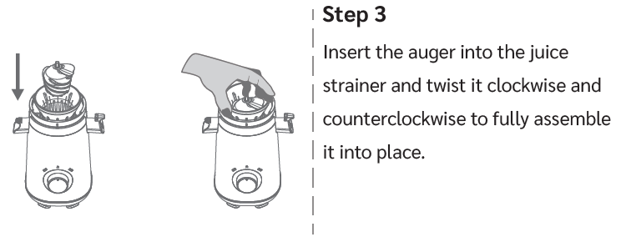


First, open the feeding cover on top of the hopper, then rotate the hopper clockwise and lock it into the juice bowl. Align the mark on the juice bowl with the mark on the hopper.
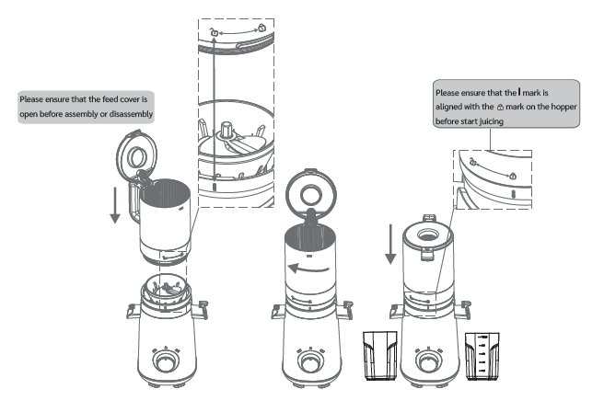

Control Knob :
Make sure the control knob is turned to the OFF position before juicing

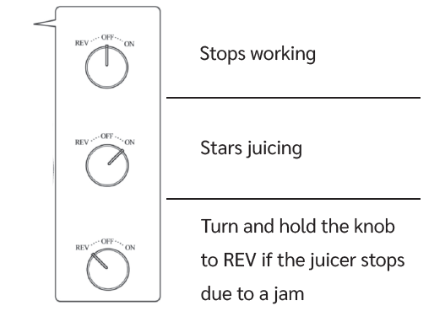

OPERATING THE SOLARA COLD PRESS JUICER

1. Before juicing, make sure the pulp and juice cup are correctly positioned.
2. Turn the knob clockwise to the "ON" mode to start juicing.
3. The top feeding chute on the feeding cover can be used to directly insert
small-sized ingredients. Then, use the pusher to gently push the ingredients. If the juicer gets clogged during the juicing process, you can rotate the knob counterclockwise to the "Reverse" mode for 3-5 seconds, and then rotate it back to the "ON" mode.
- Do not overload the Juicing Container.
- Do not use frozen ingredients.

JUICY TIPS & TRICKS

  - Avoid drinking juices with high acidity content on an empty stomach.
  - Use the pulp! Pulp can be used in baking, soups, curries – your imagination is the limit!
  - Drink your juice as soon as possible.
  - Make sure the ingredients are cut to the size to fit the juicer chute properly.
  - Do not overstuff the juicer.
  - Please make sure to clean the juicer attachments after every use.
  - Remove skins and rinds from ingredients such as citrus fruits, melons, pineapples, dragon fruit, mangoes, pomegranates, beets, ginger, papaya, and root vegetables. Juicing these with the peel/skin can make the juice sour.
  - The peel or skin can remain on for ingredients such as apples, pears, peaches, plums, cucumbers, and carrots.
  - Remove large pits and seeds from ingredients such as mangoes, plums, peaches, cherries, papayas, lemons, melons, and peppers.
  - Foods rich in fiber should be cut into much smaller units for best yield. Ex: Leafy vegetables.
  - Do not process ingredients that do not contain juice, such as bananas and avocados.
  - Do not process frozen fruits and vegetables or ice. Wait for the frozen fruits to thaw first.
  - Best Fruits & Vegetables to juice: Apples, Pineapples, Papaya, Tomatoes, Berries, Cabbage, Broccoli, Celery, Carrots, Sweet Potato, Cranberries, Parsley, Cilantro, Peppers, Cucumbers, Melons, Oranges, Lemons, other Citrus Fruits, Kale, Spinach, Ginger.

- Do not operate the juicer for more than 10 mins at a time. Always make to sure wait 10 mins before operating again.
- CAUTION: Do not use excessive force to twist the Squeezer off. If it does not unlock easily, give it time to cool down before attempting again. This is to ensure that your juicer parts are not damage/cracked due to abuse.
- Do not immerse the juicer base in water. Do not spray water on the juicer motor.
- Do not use excessive force to disassemble the juicer.

CARE & MAINTENANCE
Before cleaning, make sure that the juicer is turned off and remove from power supply. Disassemble the juicer parts (as described in the disassembly section).
Empty the pulp and juice containers.
Rinse all the accessories under running water with warm soapy water.
Never immerse the main juicer base in water. Do not spray water on the juicer body. Only wipe clean the main juicer body.
TIP: To prevent rusting/clogging, please disassemble and rinse the accessories thoroughly immediately after use and allow them to dry completely before using again.
CAUTION: Do not use any metal scrubbers/sponges to clean, as this may damage the juicer. Always clean with warm, soapy water and a soft washcloth.
Use the included cleaning brush to clean the Squeezer every time after juicing to ensure there is no leftover food buildup.
TIP: Always wash your juicer attachments immediately after juicing. In case you notice dried up food residue, soak the part in warm water for 30 mins to soften the residue for easy clean up.

TROUBLESHOOTING

Unable to disassemble the juicer.
After juicing is complete, continue to run the juicer for an additional 10-15 seconds to ensure that all the food is properly processed and is not stuck inside the juicer. Allow the juicer to cool down before attempting to disassemble as described in the disassemble section.
CAUTION: Do not use excessive force to twist the Squeezer off. If it does not unlock easily, give it time to cool down before attempting again. This is to ensure that your juicer parts are not damage/cracked due to abuse.
Juicer stopped in the middle of juicing.
As a safety feature, the juicer has an auto shut-off protective function to prevent motor overheating. Do not operate the juicer for more than 12 minutes at a time. Allow the motor to rest of 30-45 minutes to cool down between each use for a longer lifetime.
Juicer is stuck/does not operate.
Turn ‘OFF’ the juicer and unplug from power after switching off the power supply.

Plug back in after a few minutes and try the REV function for a few seconds.
SAFETY NOTE: As a safety precaution to avoid any potential injuries, the Juicer will stop when the Feed Cover is open. To resume operation, please close the Feed Cover properly.
Accessories are stained.
The juicer accessories are made from high-quality food grade materials. However, citrus fruits and vegetables like carrots, beetroots contain acids and strong coloring pigments that may be stain the accessories. However, this does not after the functionality of the juicer.
To minimize the staining, we recommend avoiding juicing large amounts of acidic foods in a single session. Always soak and clean the accessories immediately after use.
We also recommend cutting the food into smaller pieces before juicing them. This prevents food from getting stuck and gives a better juice yield.
Unable to lock in the Squeezer
Ensure that the Auger is properly installed. When properly fitted, the Auger should be upright with no gaps at the bottom.
Weird smell from the juicer
The juicer has travelled a long way to get your house. It is normal for some odor during the initial usage. If issue persists, please contact customer service.
Unusual noise of vibration during juicing.
It is normal for the juicer to vibrate slightly during juicing, especially when processing harder ingredients. This is not a malfunction and is a part of the cold press process.
It is normal to hear squeaky noises when juicing some ingredients like apples, pears, celery etc... due to high fiber content (like apple skin)
If the issue persists, please check that the Juicing Container, Auger, and the Squeezer are properly installed and locked in.

